**Module 6 Project**

**Testing plan:**

Start by simply playing a game of Tic Tac Toe by clicking the “start!” button. While playing, keep in mind the basic rules of the game. User moves first, then the board, and repeat till there is a winner. Once a space is occupied, that letter cannot be changed, and the next player must choose a space that is still available. After one of the players have three of their letters in a row (whether they are in a column or diagonal) that player wins. If any message is shown, it must be the appropriate message. “X” wins should appear if “X” wins the game. “O” wins should appear if “O” wins the game. “X” loses should appear if the other option stating that the other player won the game does not. “O” loses should appear if the other option stating that the other player won the game does not. “Tie” or something similar stating that no one won the game should appear if no one wins. “Game Over” could also be a valid message for a tie game as well and could be added to any of the mentioned messages.

**Bug1:**

After three turns, a “o” appears.

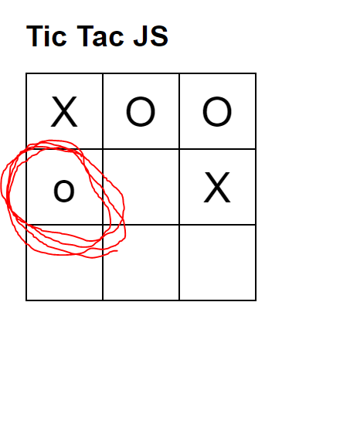

It appears there even if a “X” was already occupying that space. Also, the “o” is a lowercase “o”.

**Bug2:**

After the “o” appears, the “O” no longer occupies any spaces, and the user can occupy any available space they like.

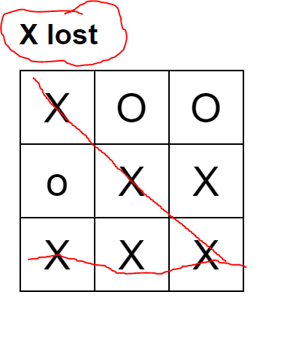

**Bug3:**

The last bug that I encountered was the board always says, “X lost” even after “X” clearly winning.

**Deployment sketch:**

